**FIRST PETER**

**The Salvation of the Soul**

**The Salvation of the soul is the total transforming work of God upon our lives, which is presently being realized in the midst of Christ like suffering, and which in the future will be unveiled in Christ like glory.**

1. 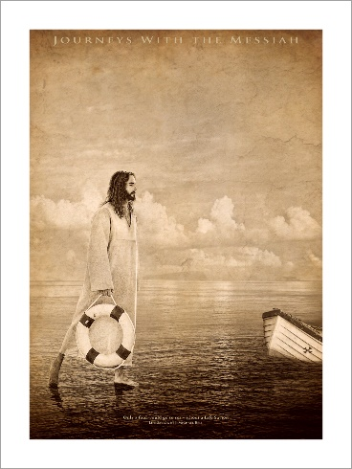**Salutation – 1:1-2**
2. **Preface: Salvation of the Soul, Our Hope and Goal – 1:3-12**
3. **The Nature of Our Salvation – 1:3-5**
4. **The Joy of Our Salvation – 1:6-9**
5. **The Appeal of Our Salvation - 1:10-12**
6. **Body: Salvation of the Soul Worked Out in Experience – 1:13 – 4:19**
7. **In Relation to God – 1:13-21**
8. **Through Obedience – 1:13-16**
9. **Through Fear – 1:17-21**
10. **In Relation to Brethren – 1:22 – 2:10**
11. **Through Constant Love – 1:22-25**
12. **Through Collective Growth – 2:1-10**
13. **With a Spiritual Appetite for the Pure Milk of the Word – 2:1-3**
14. **With an Understanding of the Magnificence of Our Privilege – 2:4-5**
15. **With an Understanding of the Magnificence of His Person – 2:6-8**
16. **With an Understanding of the Magnificence of Our Purpose – 2:9-10**
17. **In Relation to the World – 2:11 – 3:7**
18. **Through Abstinence from the Lust of the Flesh – 2:11**
19. **Through Honorable Conduct – 2:12**
20. **Through Subjection – 2:13 – 3:7**
21. **To Civil Authorities/Human Institutions – 2:13-17**
22. **For the Lord’s Sake – 2:13**
23. **For the Praise of those who do Good – 2:14**
24. **For the Silencing of the Ignorant – 2:15-16**
25. **For Honor, Love and Fear – 2:17**
26. **To your Masters/Employer – 2:18-25**
27. **For it is Commendable to God for Enduring Suffering Wrongfully – 2:18-20**
28. **For Suffering is Why We were Called to Serve – 2:19a**
29. **For Christ is Our Example to Follow for Enduring Suffering Wrongfully – 2:19b-25**
30. **To your Husbands – 3:1-7**
31. **Without a Word – 3:1-2**
32. **Without Mere Outward Appearance – 3:3**
33. **With Inward Beauty – 3:4-6**
34. **To your Wives – 3:7**
35. **With understanding – 3:7a**
36. **With Honor – 3:7b**
37. **In Relation to Life Itself – 3:8 – 4:6**
38. **Through the Experience of Blessing – 3:8-12**
39. **By Loving One Another - 3:8**
40. **By Not Returning Evil for Evil, but by Returning Evil with a Blessing – 3:9-12**
41. **Through the Experience of Suffering – 3:13 – 4:6**
42. **By Doing Good – 3:13-17**
43. **By Identifying through the Medium of Typology – 3:18-22**
44. **By having the Same Mind of Christ who Suffered in the Flesh – 4:1-6**
45. **In Relation to the Consummation of History - “the end of all things”– 4:7-19**
46. **Through Service to God – 4:7-11**
47. **With Prayer – 4:7**
48. **With Love – 4:8**
49. **With Hospitality – 4:9**
50. **With His Gift**
51. **By Giving God All the Glory**
52. **Through Suffering to God’s Glory – 4:12-19**
53. **With Great Rejoicing -4:12-13**
54. **With Anticipated Blessing – 4:14**
55. **(Not as an Evil Doer, but as a Christian – 4:15-16)**
56. **With Coming Judgment in Mind – 4:17-18**
57. **With Commitment to God – 4:19**
58. **Epilogue – A Word of Exhortation - 5:1-11**
59. **To the Elders: Shepherd the Flock - 5:1-4**
60. **To the Young Men: Submit Yourselves to the Elders - 5:5**
61. **To All: Humble Yourselves and be Prepared – 5:6-11**
62. **Humble Yourselves – 5:6-7**
63. **Be Prepare for the Devil – 5:8-9**
64. **Be Prepared for Glory**
65. **Farewell Greeting and Peace – 5:12-14**



**“After you have suffered for a little while, the God of all grace, who called you to His eternal glory in Christ, will Himself perfect, confirm, strengthen and establish you.” (1 Peter 5:10) [NASU]**



**First Peter**

**The Salvation of the Soul**